Home Screen

Workshop #02

Flutter Developer Bootcamp

# **Purpose**

This workshop demonstrates how to create a screen to list the pet categories in a grid model,bottom bar and another screen to list the profile details.

**Problem**

In your Flutter app, you're designing a pet categorization screen and user details screen. You want to implement a floating action button that, when pressed, triggers a dialog box to appear. The dialog box should contain the following elements:

* Title: "Add Post"
* Subtitle: "Do you want to add a pet"
* Two buttons: "Yes" and "No"

Your task is to implement the floating action button and the dialog box functionality as described above.

**How to Solve**

1. Checkout the workshop from Git Repo:

git clone -b <user-branch> <repo-URL>

2. Open the root folder inside VS Code

3. To build the app click the run option in the main method { }

4. You want to add a floating action button to the pet categories screen.

5. "When the user presses the floating action button, a dialog box is displayed.

# **You Will Achieve**

In this workshop, you will study Flutter basics, including widget hierarchy, Scaffold, AppBar, BottomNavigationBar, GridView, Dialogs, State Management with setState, Styling, Navigation, Handling User Input, and Reusable Widgets. You will learn to build a mobile app with a home screen featuring a grid of images and a profile screen displaying user information.

# **Screenshots**

## **Before implementation (without Floating action button & Dialog )**

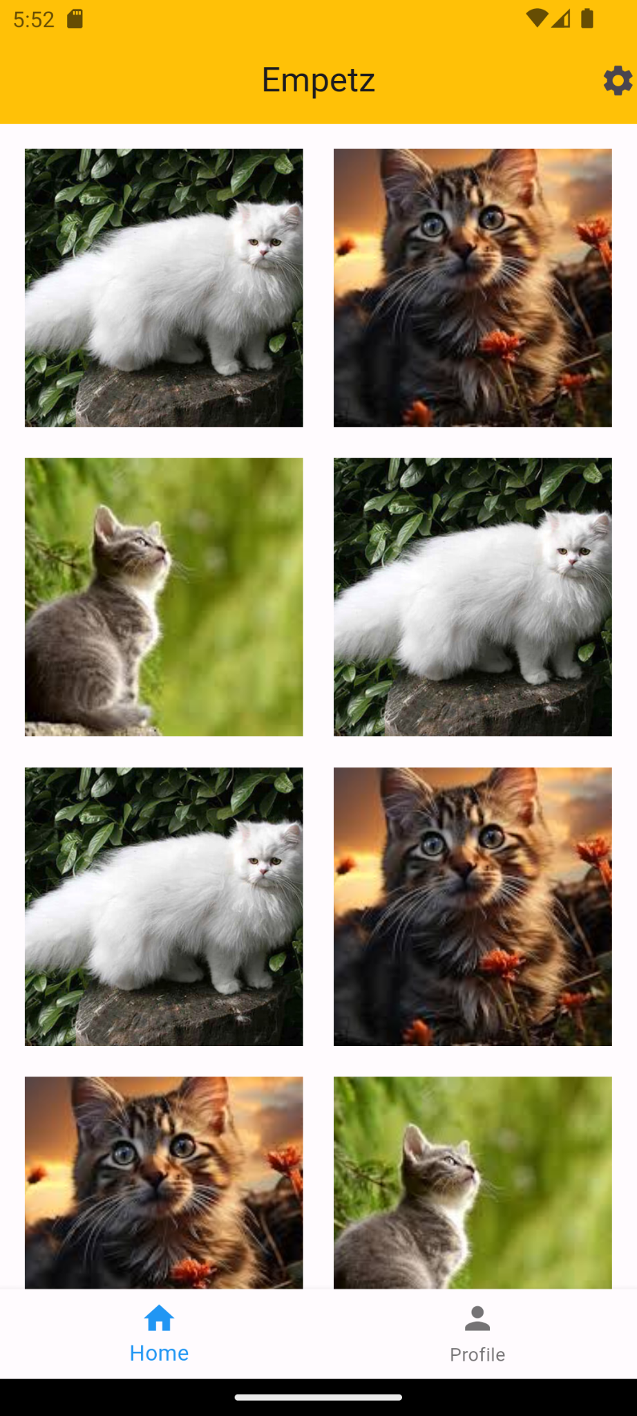 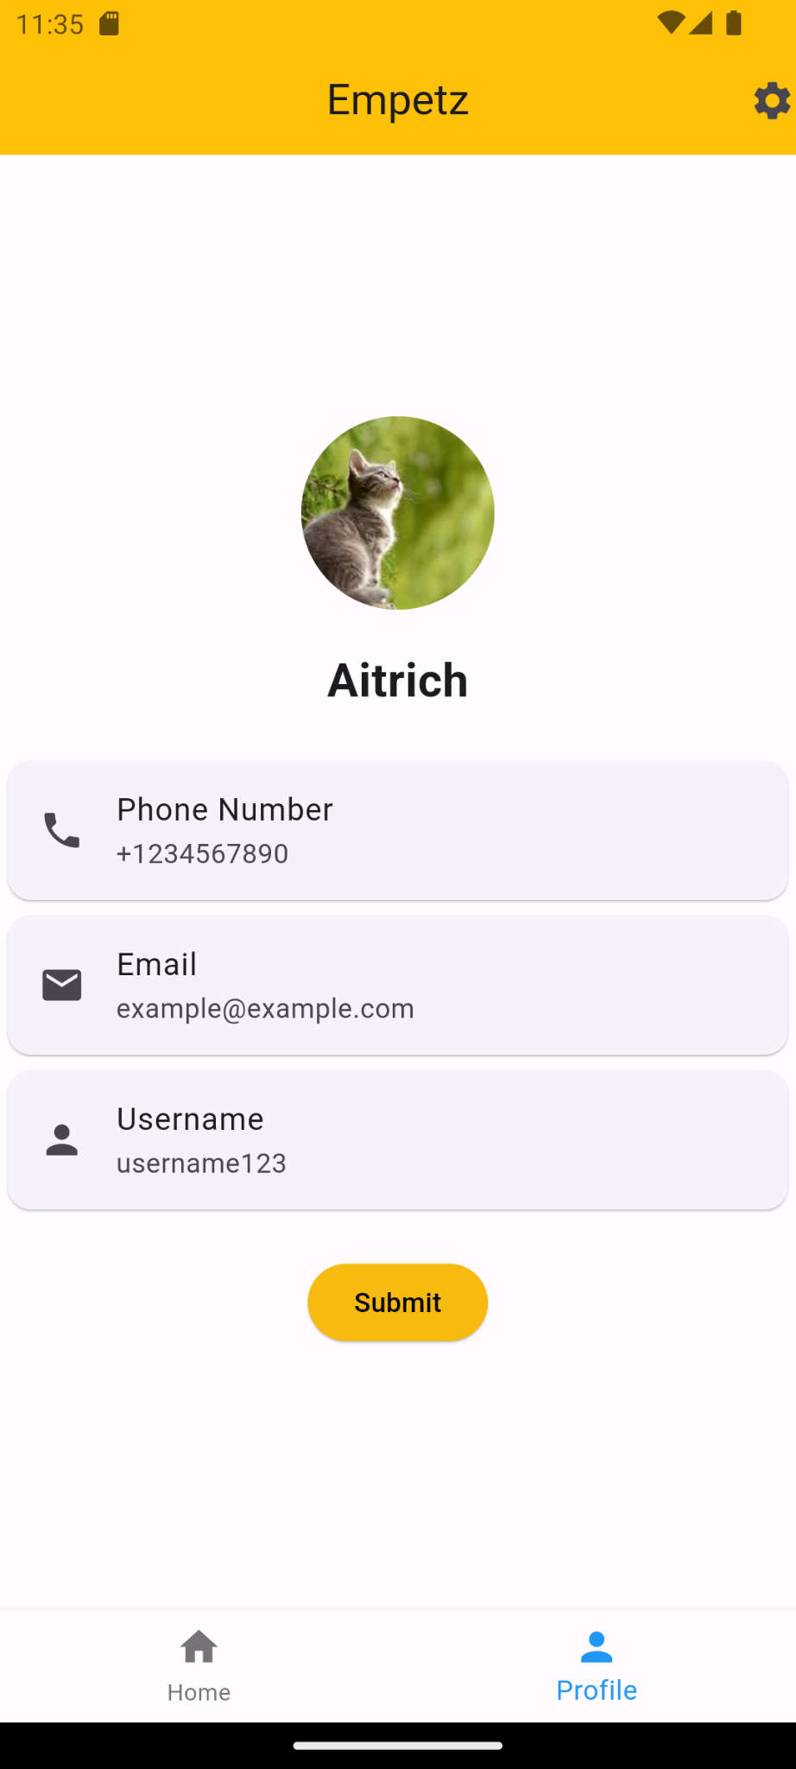

## **After implementation (With Floating action button & Dialog)**

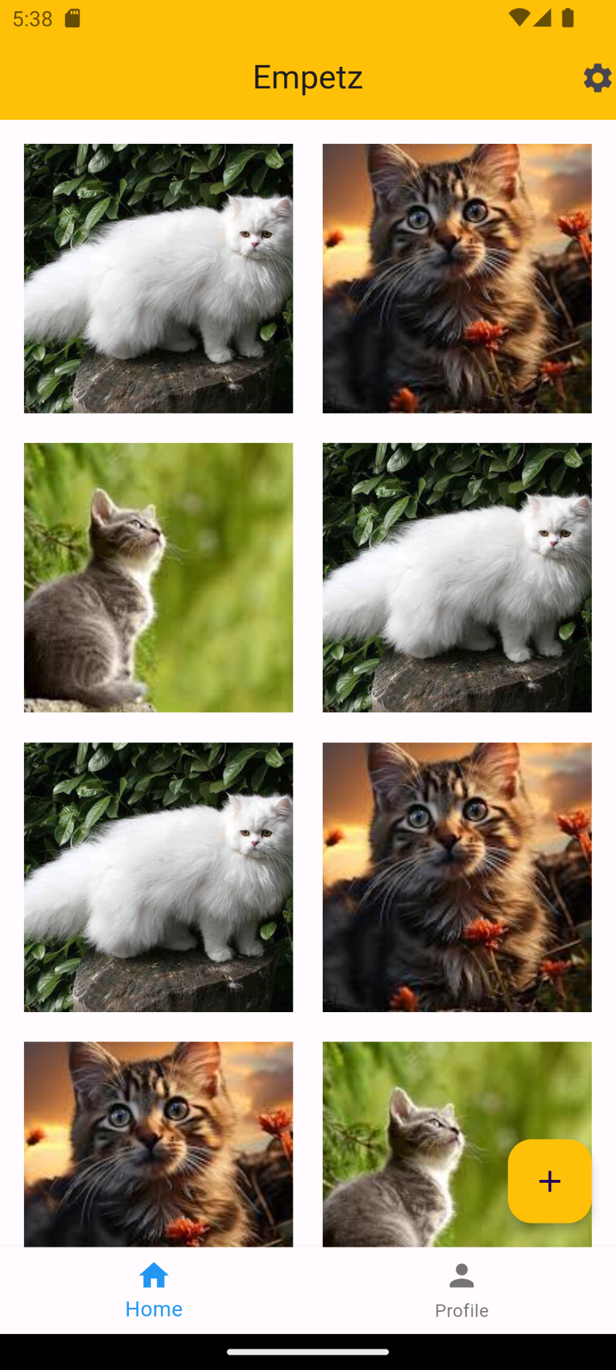 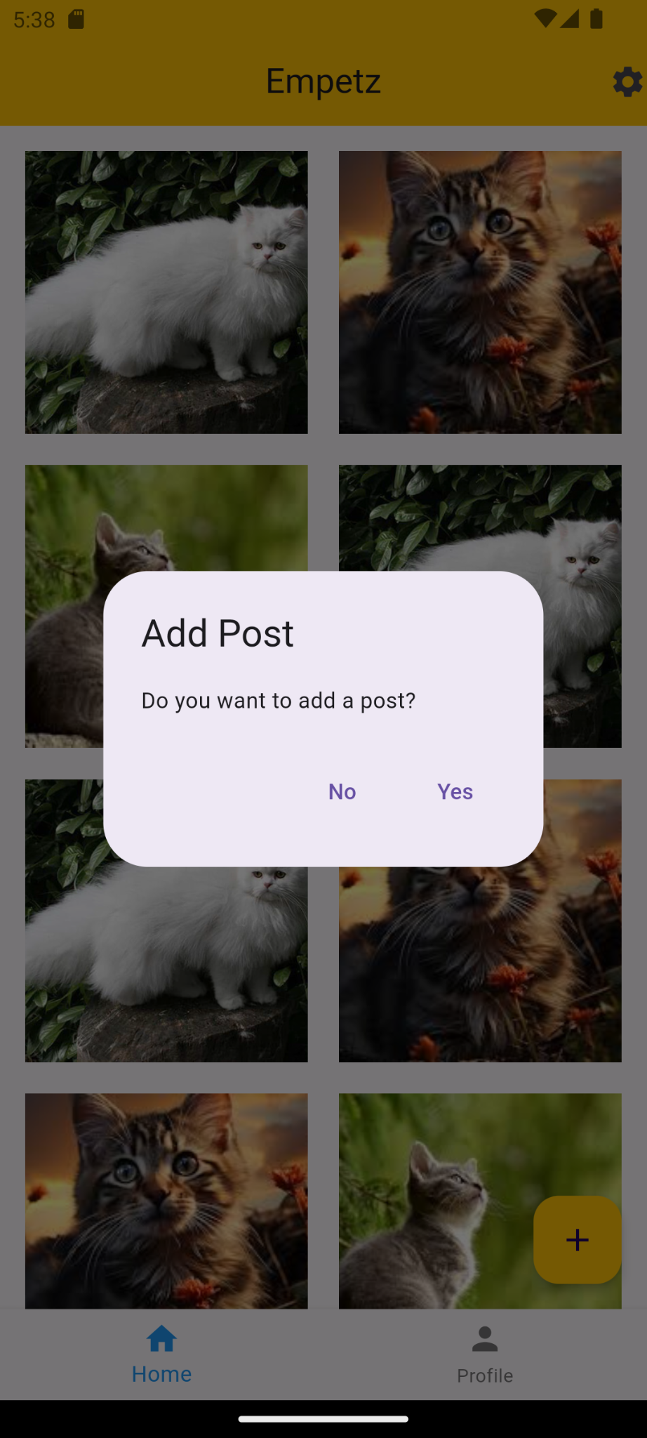



# **How to submit your workshop**

Push your project back to the same git branch using command:

<command name>

# **Happy Coding!**